|  |  |
| --- | --- |
|  | ELEKTRONICA-ICT  Project Embedded 2020-2021 |

**Autonomous golf cart**

|  |  |
| --- | --- |
| Auteurs  Product Owner | Sam Knoors, Oguzhan Erdem, Max Valkenburg, Berkan Ipek,Metehan Altintas, Abad Sethi Ur-Rehman Kazim Bozca​  Frederik Vreys |

Abstract

The Autonomous golf cart is a project meant for the transportation from and to parking lots that are located far from an office building, schools and city centres. This all needs to be comfortable, efficient and safe. The aim is to make this vehicle commute between two points without a human driver. Only in some circumstances will it happen that there is an unforeseen object in the path of the cart, when this happens, it is necessary that the cart moves around it with all the safety aspects in mind. All of this happens with the use of cameras and radars combined with an artificial intelligence (AI). All the Physical actions are controlled by PLC. The PLC receives commands from the observation system and executes the necessary actions, for example increase or decrease the throttle or steer in a certain angle. To do this research there is a separate testbench to test some functions and measure all the movements, and apply this to the AI. The advantage of this separate setup is that two teams can work on the same project and that tests can executed without a driving golfcart.

This paper includes the part that is responsible for the PLC, user interface, and the communication between these and the artificial intelligence. The research question is “*What are the minimum requirements to design a system that is both safe and easy to use for an autonomous golf cart?*”

Index

1 Introduction 2

2 Material and methods 2

3 Results 2

4 Discussion 2

5 Conclusion 2

6 Reference list 2

7 Attachment 3

# Introduction

Bachelorproef fase 1 en 4

Aanleiding onderzoek? Baken je onderwerp duidelijk af. Wat bespreek je wel en niet?

* Wat is de praktische relevantie van je onderzoek?
* Wat zijn de belangrijkste (wetenschappelijke) artikelen die je gebruikt?
* Doelstelling
* Probleemstelling
* Leeswijzer waarin je bespreekt wat je per hoofdstuk afhandelt

Minimaal 150 woorden en aangeraden 300 woorden (meer mag)

# Materials and methods

Bachelorproef fase 1

* Geen afbeeldingen maar wel lijsten en flow diagrammen en architectuur schema’s
* Geen uitleg over de componenten en de technieken die standaard geweten zijn à ref.

Minimaal 750 woorden en aangeraden 2000 woorden (meer mag)

Controlling the cart is a Beckhoff PLC (Programmable logic controller) in combination with a Jetson nano and STM32. We decided on these devices because they are known and have good experience with them. This makes programming, finding documentation and troubleshooting easier and more streamlined.

(nog iets over keuze plc en wrm jetson nano ?)

## Flowdiagram

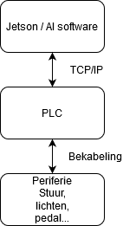Ik weet dat foto nederlands is, is gwn ff placeholder :D

At the heart of this project lies the jetson nano, it runs the AI and tells the PLC how to control the cart. The PLC in turn controls the steering motor, the throttle, brakes, and various lights around the cart.

The jetson and plc communicate with another through tcp/ip. this technologie was chosen because safety is a top priority and this way, we ensure data is transmitted fully. As the arrow on figure2 shows this communication goes both ways. If for example someone presses an emergency stop or turns the steering wheel while the cart is driving autonomously, the jetson needs to know to stop the AI and return to manual operation.

## 4G-Module by mikroe and U-blox

The 4G LTE click by mikroe is a module that supports cellular networking and communication using three LTE bands and GSM bands. It has also TCP/UDP and HTTP/HTTPS communication protocols. The chip they are using is a compact LARA-R2 series from u-blox. The specific model of the chip is the LARA-R211, that supports all this above. Mikroe created a click board so you can use it on their development board, through USB (UART) or using jumper wires. These pins are required: GND, 3V3, 5V, PWK, RX, TX. It supports any device that has Android/Linux. If you want it working on Windows, you need to install a driver that available is on their [site](https://www.mikroe.com/).

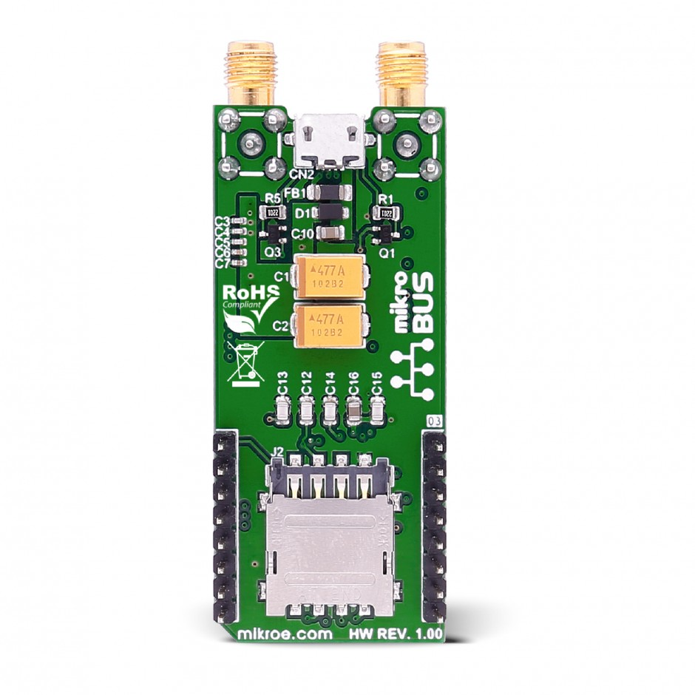

## Website

The Adminer database(recommended) has been used to register customers (foto), this system will offer a tidier user interface, better support for MySQL features, higher performance and more security. The application’s registration system communicates with the database by means of a PHP script(foto).

The services of google cloud platform has also been used which offers various api keys for using google applications. In this case the google maps API has been used, a key for this api has been requested at the platform. The key is free up to 5000 requests/month, when this is exceeded, a bill is attached.

## PLC

The PLC used in this project is a CX9020 from “Beckhoff” and can be programmed with the “Twincat” IDE. To get things done with the PLC, there are some modular modules that can be clicked onto this. To control the lighting, switch between forward and reverse you need digital IO modules and to steer you need a Stepper and therefore a stepper drive module. Explained in detail later. In terms of safety, “Beckhoff” has some special safety modules that ensure that all running processes are safely terminated when the emergency button is pressed.

### Inputs and outputs

The PLC takes over all the peripherals of the existing controller in the cart. To do this there are some IO modules used. First of all, the drive direction, this is manually controlled by a bistable 3 points switch to choose whenever you want to drive forward, backward or neither of these and put the golf cart in neutral. Second the cart must be able to turn the lights on and control the turning sign. To do all this, the plc needs a digital IO module in combination with a relay bord to handle the current. The modules used in this project are the “EL1008” for all the inputs and the “EL2008” for all the outputs. The relay bord is specially designed for the golfcart and contains 8 relay terminals see 2.4.2 for more information.

When it comes to controlling the speed, interception of the e-pedal signal is needed. This pedal gives out a zero to five-volt signal using a potentiometer. To read this value the PLC needs an analog input module. In this project a “EL3062” module is used. And turns the signal to a value between 0 and 10246. To pass this value to motor controller, an analog output module (EL8888) is used. This gives out a voltage between 0 and 10 volt using PWM.

### Relays PCB

To control the main functions such as the electric gas pedal, low beam, high beam and the turn signals, an adequate number of relays are essential to the project. These relays will act like a switch to control the main functions of the vehicle. The PLC is the controlling unit for these. All of the relays will be installed on a printed circuit board by solder.

The early edition(citaat) of the PCB that has not been tested or soldered yet, will be analysed for potential imperfections. The relays and headers will be test fitted on to the PCB, to make sure they actually fit. Thereafter, all relays will be tested individually to make sure they are installed and working properly.

### Motion

When it comes to steering, the AI and thus the PLC have full control of the golfcart. But in case of emergency, a human passenger can take over the steering wheel and the PLC will detect this and goes to emergency mode. A stepper and a chain mechanism is used to take over the steering wheel. For now, this is assembled and placed on to the testbench to test and optimize the already written code. More about the testbench is described later on.

### Safety

### Communication with AI

## Testbench

The testbench of the golfcart is made of a basic race game /simulation setup and modified with all the features that are needed to test all the important functions of the autonomous golfcart. The setup exists out a e-throttle, steering mechanism including a stepper and the PLC. The purpose of using a testbench is, first of all that it is safer than test on the real cart and second the bench can be used to test newly written code before putting it on to the golfcart. A third benefit of using this is that it can be used as exercise setup for other projects.

# Results

Bachelorproef fase 2 en 3

* Resultaten per onderzoeksmethode of deelonderwerp per alinea
* Effectief uitgevoerd, zonder opinie want deze staan onder discussie
* Kan print screens en schema’s bevatten
* Meerdere projecten of deelonderwerpen worden als andere alinea’s uitgeschreven

Minimaal 250 woorden en aangeraden 1000 woorden (meer mag)

## Data 4G-module

The purpose of this 4G-module is for supporting the Jetson Nano an internet connection. Through a mobile broadband connection, it was able to connect the module with the Jetson Nano. Because the Jetson Nano is a Linux based board, the module didn’t need any driver or installation to get it worked. The module is connected with the Jetson using an USB cable. The cable supports UART obviously, so it sends data to the Jetson.   
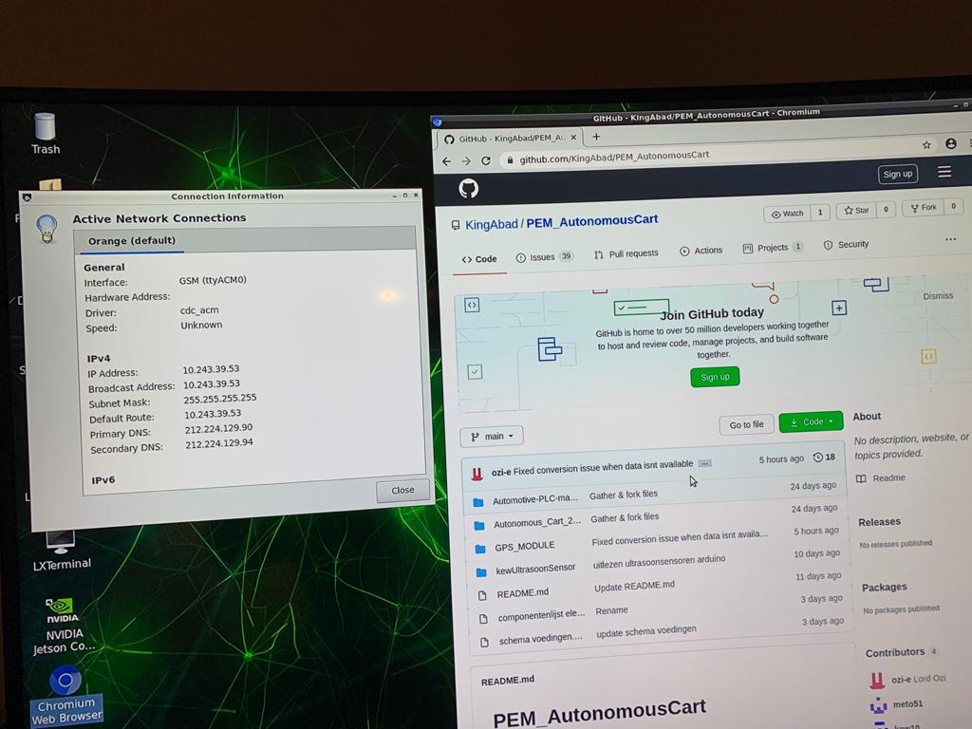

On the left side of the picture above you can see an “Active Network Connection” window, here you can see that the module is connected and running. On the right side of the picture,

you can see another window where the internet connection really does work.

## Website

An online platform is also created for people who want to use the autonomous cart. It works as follows: first of all, the customer needs to register on the online website so that he/she has a personal account.

The customer can now send requests to the cart to be picked up and make personal adjustments to the account that are beneficial to him/her such as adding a route that is frequently used by the user in the category of favorite routes.

There is also a google maps API with fixed route’s implemented in the application, this makes the application user-friendly and easy to use for the customer.

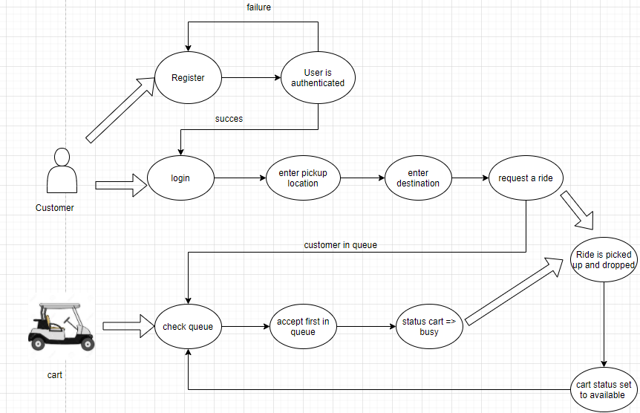

Figure 1

# Discussion

Bachelorproef fase 2 en 3

* Validiteit van het onderzoek
* Resultaten koppelen aan de verwachtingen
* Verklaring van de resultaten
* Nieuwe inzichten
* Future work

Minimaal 750 woorden en aangeraden 2000 woorden (meer mag)

# Conclusion

Bachelorproef fase 4

* Aanbevelingen
* Adviesrapport

Minimaal 150 woorden en maximaal 300 woorden

# Bibliografieën

**Het huidige document heeft geen bronnen.**

# Bijlage

* Informatie die relevant is maar niet binnen de AN past

Afgeprint kan bijlage zich beperken tot een opsomming die te raadplegen is digitaal.